**WEB TECHNOLOGY LAB (CS33204)**

**WEEK-2**

**Name: Shishu**

**Reg:-2020CA089**

1. Create a table to show your class time table.

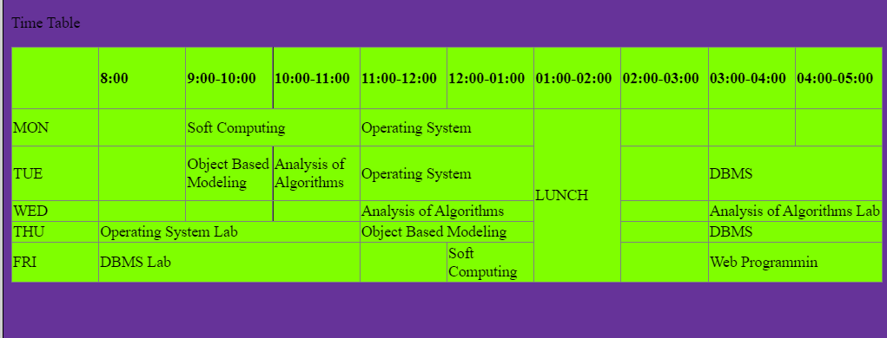

<!DOCTYPE html>

<html lang="en">

<head>

    <meta charset="UTF-8">

    <meta http-equiv="X-UA-Compatible" content="IE=edge">

    <meta name="viewport" content="width=device-width, initial-scale=1.0">

    <title>Document</title>

</head>

<body>

    <p>Time Table</p>

    <div id="timetable" style="justify-content: center;">

        <table style="border-collapse: collapse;background-color: chartreuse ;width: 100%; height: 180px;" border="1">

            <tbody>

            <tr style="height: 36px;">

            <td style="width: 10%; height: 36px;">&nbsp;</td>

            <td style="width: 10%; height: 36px;">

            <h4>8:00</h4>

            </td>

            <td style="width: 10%; height: 36px;">

            <h4>9:00-10:00</h4>

            </td>

            <td style="width: 10%; height: 36px;">

            <h4>10:00-11:00</h4>

            </td>

            <td style="width: 10%; height: 36px;">

            <h4>11:00-12:00</h4>

            </td>

            <td style="width: 10%; height: 36px;">

            <h4>12:00-01:00</h4>

            </td>

            <td style="width: 10%; height: 36px;">

            <h4>01:00-02:00</h4>

            </td>

            <td style="width: 10%; height: 36px;">

            <h4>02:00-03:00</h4>

            </td>

            <td style="width: 10%; height: 36px;">

            <h4>03:00-04:00</h4>

            </td>

            <td style="width: 10%; height: 36px;">

            <h4>04:00-05:00</h4>

            </td>

            </tr>

            <tr style="height: 36px;">

            <td style="width: 10%; height: 36px;">MON</td>

            <td style="width: 10%; height: 36px;">&nbsp;</td>

            <td style="width: 10%; height: 36px;" colspan="2">Soft Computing</td>

            <td style="width: 10%; height: 36px;" colspan="2">Operating System</td>

            <td style="width: 10%; height: 144px;" rowspan="5">LUNCH</td>

            <td style="width: 10%; height: 36px;">&nbsp;</td>

            <td style="width: 10%; height: 36px;">&nbsp;</td>

            <td style="width: 10%; height: 36px;">&nbsp;</td>

            </tr>

            <tr style="height: 54px;">

            <td style="width: 10%; height: 54px;">TUE</td>

            <td style="width: 10%; height: 54px;">&nbsp;</td>

            <td style="width: 10%; height: 54px;">Object Based Modeling</td>

            <td style="width: 10%; height: 54px;">Analysis of Algorithms</td>

            <td style="width: 10%; height: 54px;" colspan="2">Operating System</td>

            <td style="width: 10%; height: 54px;">&nbsp;</td>

            <td style="width: 10%; height: 54px;" colspan="2">DBMS</td>

            </tr>

            <tr style="height: 18px;">

            <td style="width: 10%; height: 18px;">WED</td>

            <td style="width: 10%; height: 18px;">&nbsp;</td>

            <td style="width: 10%; height: 18px;">&nbsp;</td>

            <td style="width: 10%; height: 18px;">&nbsp;</td>

            <td style="width: 10%; height: 18px;" colspan="2">Analysis of Algorithms</td>

            <td style="width: 10%; height: 18px;">&nbsp;</td>

            <td style="width: 10%; height: 18px;" colspan="2">Analysis of Algorithms Lab</td>

            </tr>

            <tr style="height: 18px;">

            <td style="width: 10%; height: 18px;">THU</td>

            <td style="width: 10%; height: 18px;" colspan="3">Operating System Lab</td>

            <td style="width: 10%; height: 18px;" colspan="2">Object Based Modeling</td>

            <td style="width: 10%; height: 18px;">&nbsp;</td>

            <td style="width: 10%; height: 18px;" colspan="2">DBMS</td>

            </tr>

            <tr style="height: 18px;">

            <td style="width: 10%; height: 18px;">FRI</td>

            <td style="width: 10%; height: 18px;" colspan="3">DBMS Lab</td>

            <td style="width: 10%; height: 18px;">&nbsp;</td>

            <td style="width: 10%; height: 18px;">Soft Computing</td>

            <td style="width: 10%; height: 18px;">&nbsp;</td>

            <td style="width: 10%; height: 18px;" colspan="2">Web Programmin</td>

            </tr>

            </tbody>

            </table>

    </div>

</body>

</html>

1. Use frames such that page is divided into 3 frames 20% on left to show contents of pages, 60% in center to show body of page, remaining on right to show remarks.

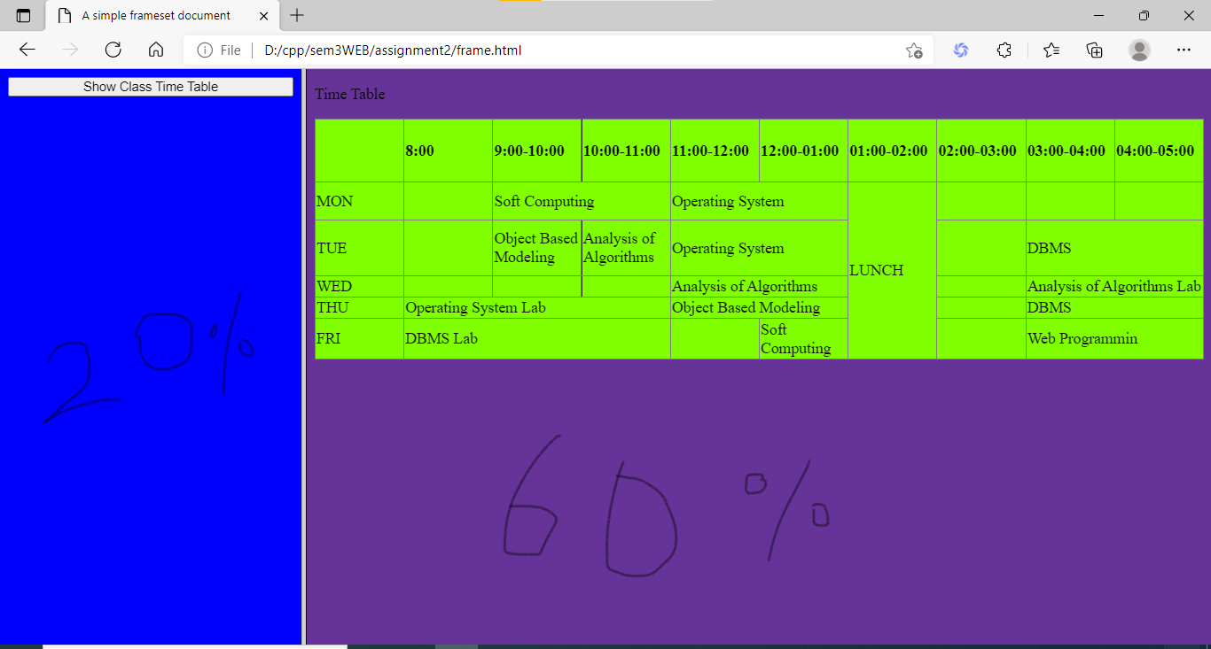

<!DOCTYPE HTML PUBLIC "-//W3C//DTD HTML 4.01 Frameset//EN"

   "http://www.w3.org/TR/html4/frameset.dtd">

<HTML>

<HEAD>

<TITLE>A simple frameset document</TITLE>

</HEAD>

<FRAMESET cols="20%, 60%">

    <FRAME src="leftside20.html" name="20% frame" style="background-color: blue;"/>

    <FRAME src="rightside60.html" name="60% frame" style="background-color: rebeccapurple;"/>

</FRAMESET>

</HTML>

1. Apply various colours to suitably distinguish key words, also apply font styling like italics, underline and two other fonts to words you find appropriate, also use header tags.

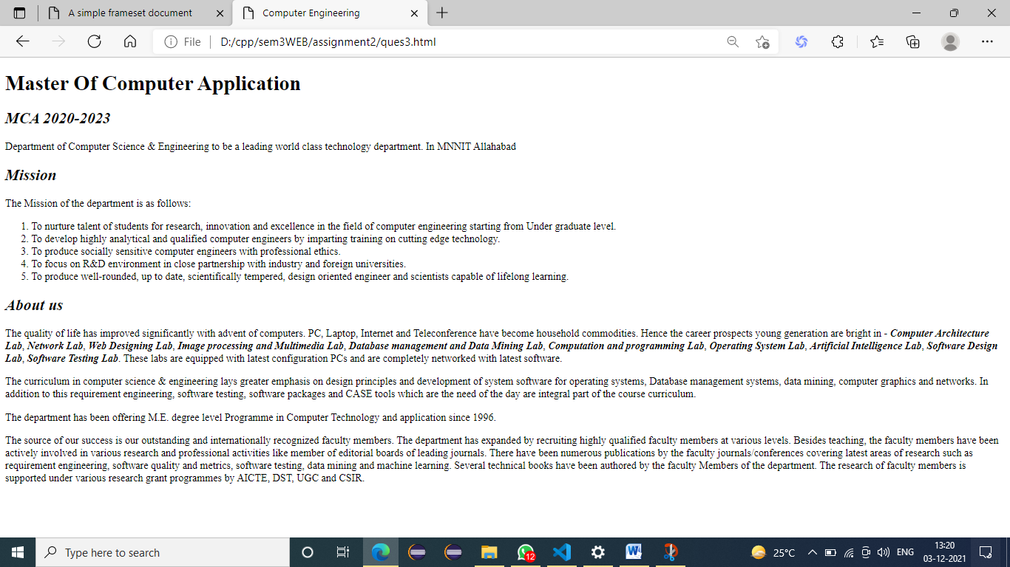

Ques3.html

<!DOCTYPE html>

<html lang="en">

<head>

    <meta charset="UTF-8">

    <meta name="viewport" content="width=device-width, initial-scale=1.0">

    <title>Computer Engineering</title>

    <link rel="stylesheet" type="text/css" href="./ques3.css">

    <link href="https://fonts.googleapis.com/css2?family=Lato:wght@100;300;400&display=swap" rel="stylesheet">

</head>

<body>

    <div class="header">

        <h1>Master Of Computer Application</h1>

    </div>

    <div class="content">

        <em>

            <h2>MCA 2020-2023</h2>

        </em>

        <p>

            Department of Computer Science & Engineering to be a leading world class technology department.

            In MNNIT Allahabad

        </p>

        <em>

            <h2>Mission</h2>

        </em>

        <p>

            The Mission of the department is as follows:

        <ol>

            <li>

                To nurture talent of students for research, innovation and excellence in the field of computer

                engineering starting from Under graduate level.

            </li>

            <li>

                To develop highly analytical and qualified computer engineers by imparting training on cutting edge

                technology.

            </li>

            <li>

                To produce socially sensitive computer engineers with professional ethics.

            </li>

            <li>

                To focus on R&D environment in close partnership with industry and foreign universities.

            </li>

            <li>

                To produce well-rounded, up to date, scientifically tempered, design oriented engineer and scientists

                capable of lifelong learning.

            </li>

        </ol>

        </p>

            <em>

                <h2>About us</h2>

            </em>

        <p>

            The quality of life has improved significantly with advent of computers. PC, Laptop, Internet and

            Teleconference have become household commodities. Hence the career prospects young generation are bright in

          -

            <b><em>Computer Architecture Lab</em></b>, <b><em>Network Lab</em></b>, <b><em>Web Designing Lab</em></b>,

            <b><em>Image processing and Multimedia Lab</em></b>,

            <b><em>Database management and Data Mining Lab</em></b>, <b><em>Computation and programming Lab</em></b>, <b><em>Operating System Lab</em></b>, <b><em>Artificial

                Intelligence Lab</em></b>,

                <b><em>Software Design Lab</em></b>,

                <b><em>Software Testing Lab</em></b>. These labs are equipped with latest

            configuration PCs and are completely networked with latest software.

        </p>

        <p>

            The curriculum in computer science & engineering lays greater emphasis on design principles and development

            of system software for operating systems, Database management systems, data mining, computer graphics and

            networks. In addition to this requirement engineering, software testing, software packages and CASE tools

            which are the need of the day are integral part of the course curriculum.

        </p>

        <p>

            The department has been offering M.E. degree level Programme in Computer Technology and application since

            1996.

        </p>

        <p>

            The source of our success is our outstanding and internationally recognized faculty members. The department

            has expanded by recruiting highly qualified faculty members at various levels. Besides teaching, the faculty

            members have been actively involved in various research and professional activities like member of editorial

            boards of leading journals. There have been numerous publications by the faculty journals/conferences

            covering latest areas of research such as requirement engineering, software quality and metrics, software

            testing, data mining and machine learning. Several technical books have been authored by the faculty Members

            of the department. The research of faculty members is supported under various research grant programmes by

            AICTE, DST, UGC and CSIR.

        </p>

    </div>

</body>

</html>

Ques3.css

* {

    margin : 0;

    padding: 0;

    text-rendering: optimizeLegibility;

    font-family: 'Lato', sans-serif;

}

body {

    display: flex;

    height: 100vh;

    flex-direction: column;

    justify-content: space-evenly;

    align-items: center;

    margin: 0 20%;

    background-color: #2c2c2c;

    color: rgb(211, 211, 211);

}

.header {

    display: flex;

}

.content {

    display: flex;

    flex-direction: column;

    align-items: flex-start;

}

.content p {

    line-height: 25px;

}

.content ol {

    margin-left: 20px;

}

b em {

    color: #de8339;

    text-decoration: underline;

}

1. Insert an image and create a link such that clicking on image takes user to other page



Ques4.html

<!DOCTYPE html>

<html lang="en">

<head>

    <meta charset="UTF-8">

    <meta name="viewport" content="width=device-width, initial-scale=1.0">

    <link href="https://fonts.googleapis.com/css2?family=Lato:wght@100;300;400&display=swap" rel="stylesheet">

    <link rel="stylesheet" href="./main.css" type="text/css">

    <title>Image experiment</title>

</head>

<body>

    <div id="content">

        <h2>Click the image below to go to MNNIT</h2>

        <div id="link">

            <a href="http://www.mnnit.ac.in/" target="_blank">

                <img src="./img/mnnit.jpg" alt="Google Logo"/>

            </a>

        </div>

        <button id="top" onclick="goToTop()">Go to Top</button>

    </div>

    <script>

        function goToTop() {

            document.body.scrollTop = 0;

            document.documentElement.scrollTop = 0;

        }

    </script>

</body>

</html>

Ques4.css

* {

    margin : 0;

    padding: 0;

    text-rendering: optimizeLegibility;

    font-family: 'Lato', Arial, Helvetica, sans-serif;

    color: #fff;

}

body {

    height: 120vh;

    background-color: #2c2c2c;

}

#content, a {

    height: 100%;

    display: flex;

    flex-direction: column;

    justify-content: space-around;

    align-items: center;

}

img {

    width: 50%;

}

button {

    background: #1f6bb3;

    border: none;

    padding: 10px 10px;

    cursor: pointer;

    border-radius: 20px;

    font-size: 15px;

}

1. Write an HTML page that contains a selection box with a list of 5 countries, when the user selects a country, its capital should be printed next to the list; Add CSS to customize the properties of the font of the capital (color, bold and font size).

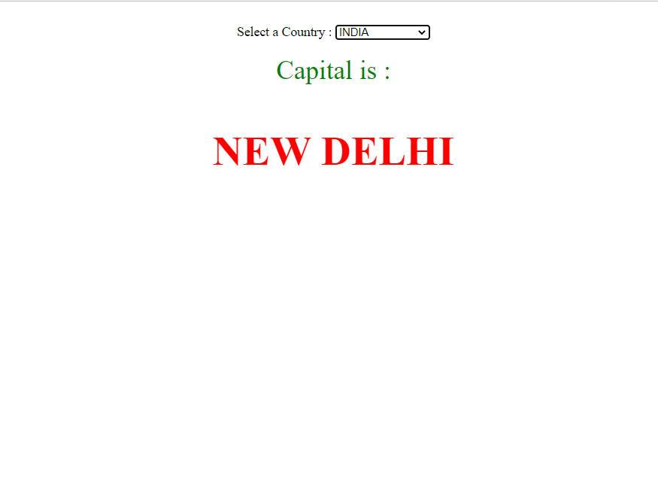

fiveCountry.html

<html>

<head>

    <title>capitals of countries</title>

    <style>

        p {

            color: red;

            font-weight: bold;

            font-size: 50;

        }

    </style>

    <script language="javascript">

        function capital() {

            var cunt = document.forms["frm1"].country.value;

            var capital = " Please select any country ";

            if (cunt == "india") {

                capital = "NEW DELHI";

            }

            if (cunt == "china") {

                capital = "BEIJING";

            }

            if (cunt == "pakistan") {

                capital = "ISLAMABAD";

            }

            if (cunt == "bangladesh") {

                capital = "DHAKA";

            }

            if (cunt == "japan") {

                capital = "TOKYO";

            }

            if (cunt == "select") {

                capital = "Please select any country";

            }

            document.getElementById("capt").innerHTML = capital;

        }

    </script>

</head>

<body>

    <form name="frm1">

        <br />

        <center>

            Select a Country : <select name="country" onchange="capital()">

                <option value="select">--SELECT--</option>

                <option value="india">INDIA</option>

                <option value="china">CHINA</option>

                <option value="pakistan">PAKISTAN</option>

                <option value="bangladesh">BANGLADESH</option>

                <option value="japan">JAPAN</option>

            </select>

            <br />

            <br />

            <font color="green" size="6">Capital is :</font>

            <p id="capt"></p>

        </center>

    </form>

</body>

</html>

1. Write an HTML code to demonstrate the usage of inline CSS.

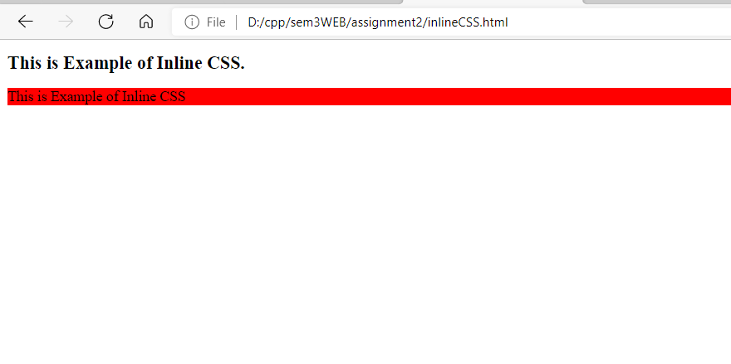

**Inlinecss.html**

<!DOCTYPE html>

<html>

   <head>

      <title>HTML Inline CSS</title>

   </head>

   <body>

      <h1 style="font-size: 20px;">

        This is Example of Inline CSS.

      </h1>

      <p style="background-color: red;">This is Example of Inline CSS</p>

   </body>

</html>

1. Write an HTML code to demonstrate the usage of internal CSS.

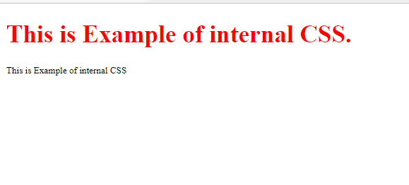

**Internalcss.html**

<!DOCTYPE html>

<html>

   <head>

      <style>

         h1 {color: red;}

         p {font-size: 12px;}

      </style>

   </head>

   <body>

      <h1> This is Example of internal CSS.</h1>

      <p>This is Example of internal CSS</p>

   </body>

</html>

1. Write an HTML code to demonstrate the usage of external CSS.

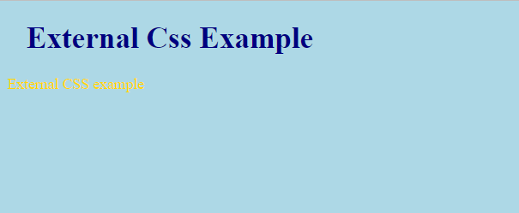 <!DOCTYPE html>

<html>

   <head>

     <link rel="stylesheet" href="external.css">

   </head>

   <body>

      <h1>External Css Example</h1>

      <p>External CSS example</p>

   </body>

</html>

**External.css**

body {

    background-color: lightblue;

  }

  h1 {

    color: navy;

    margin-left: 20px;

  }

  p{

      color:gold

  }

1. Use <span> and <div> tags to provide a layout to the your college infrastructure.

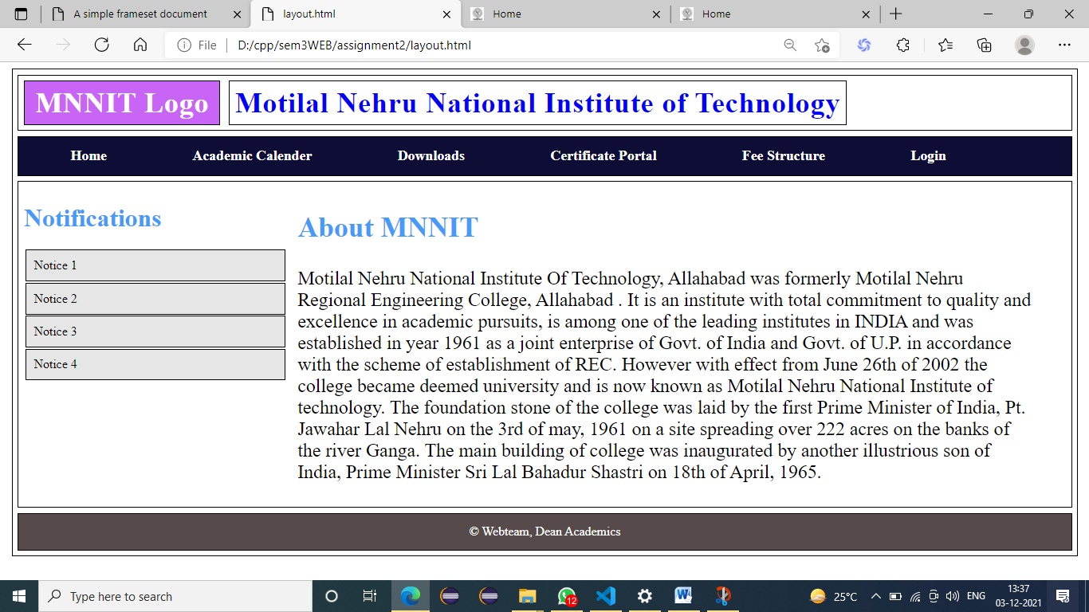

**Layout.html**

<html>

    <head>

        <link rel="stylesheet" href="style.css">

    </head>

    <body>

        <div class="body">

            <div class="header">

                <span class="logo">MNNIT Logo</span>

                <span class="name">Motilal Nehru National Institute of Technology</span>

            </div>

            <div class="nav">

                <span>Home</span>

                <span>Academic Calender</span>

                <span>Downloads</span>

                <span>Certificate Portal</span>

                <span>Fee Structure</span>

                <span>Login</span>

            </div>

            <div class="main">

                <div class="sidenav">

                    <h1 style="color:rgb(69, 154, 250); font-weight: 700;">Notifications</h1>

                    <div class="notice">Notice 1</div>

                    <div class="notice">Notice 2</div>

                    <div class="notice">Notice 3</div>

                    <div class="notice">Notice 4</div>

                </div>

                <div class="about">

                    <h2 style="color:rgb(69, 154, 250); font-weight: 700;">About MNNIT</h2>

                    <p>Motilal Nehru National Institute Of Technology, Allahabad was formerly Motilal Nehru Regional Engineering College, Allahabad . It is an institute with total commitment to quality and excellence in academic pursuits, is among one of the leading institutes in INDIA and was established in year 1961 as a joint enterprise of Govt. of India and Govt. of U.P. in accordance with the scheme of establishment of REC. However with effect from June 26th of 2002 the college became deemed university and is now known as Motilal Nehru National Institute of technology.

The foundation stone of the college was laid by the first Prime Minister of India, Pt. Jawahar Lal Nehru on the 3rd of may, 1961 on a site spreading over 222 acres on the banks of the river Ganga. The main building of college was inaugurated by another illustrious son of India, Prime Minister Sri Lal Bahadur Shastri on 18th of April, 1965.</p>

                </div>

            </div>

            <div class="footer">

                © Webteam, Dean Academics

            </div>

        </div>

    </body>

</html>

**Style.css**

div, span{

    border: 1px solid black;

    margin: 0.5%;

}

.header{

    padding: 1% 0;

}

.logo{

    padding: 0.5% 1%;

    height: 180px;

    background-color: rgb(200, 101, 246);

    font-size: 36px;

    letter-spacing: 1px;

    font-weight: 700;

    color: white;

}

.name{

    font-size: 36px;

    letter-spacing: 1px;

    font-weight: 700;

    color: blue;

    margin: 2% 2% 2% 0;

    padding: 0.5%;

}

.nav{

    padding: 1%;

    background-color: rgb(13, 13, 54);

}

.nav span{

    padding: 1% 2%;

    margin: 0.5% 2%;

    color: white;

    border: none;

    font-weight: 700;

    font-size: large;

    cursor: pointer;

}

.main{

    display: flex;

}

.sidenav{

    height: 80%;

    width: 25%;

    border: none;

}

.notice{

    padding: 3%;

    background-color: rgb(230, 230, 230);

    cursor:pointer;

}

.about{

    width: 70%;

    font-size: 24px;

    font-family: 'Times New Roman', Times, serif;

    border: None;

}

.footer{

    text-align: center;

    color: white;

    padding: 1%;

    background-color: rgb(87, 74, 74);

}